# **Absolute Encoder Signal Adapting Cables**

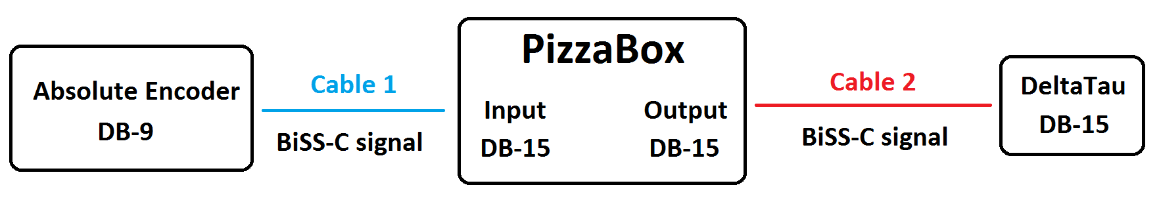

Cable 1: connect Renishaw Absolute encoder (BiSS-C) to Pizzabox input.

|  |  |
| --- | --- |
| **Signal on encoder connector** | **Signal on Pizzabox input** |
| Power (5V) | Power |
| GND | GND |
| MA+ | A+ |
| MA- | A- |
| SLO+ | B+ |
| SLO- | B- |

Cable 2: connect Pizzabox output to DeltaTau input.

|  |  |
| --- | --- |
| **Signal on Pizzabox input** | **Signal on DeltaTau input** |
| Power | Power (5V) |
| GND | GND |
| A+ | MA+ |
| A- | MA- |
| B+ | SLO+ |
| B- | SLO- |